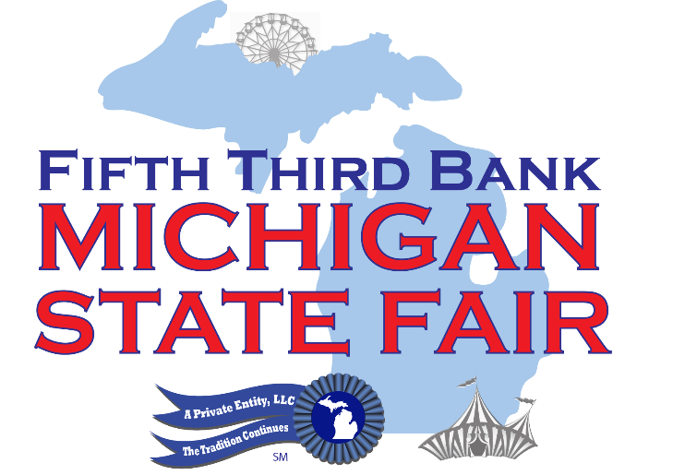

Second Annual Michigan State Fair Parade
Labor Day, Monday, September 5, 2016 at 10:00 AM in Novi

Novi, MI: The Second Annual Michigan State Fair Parade is scheduled for Labor Day, Monday, September 5, 2016 at 10:00 AM, rain or shine. The Detroit Shriners have partnered with the Michigan State Fair for this family fun event; approximately 300 Shriners with their Parade Units will be in attendance!

Area residents, businesses, street performers, and community groups are invited to join the fun as the State Fair celebrates Michigan Agriculture, Communities, and Businesses--- and the final holiday weekend of the summer! Novi Mayor Bob Gatt is very enthusiastic about all the fun coming to town, “There is NO BETTER PLACE in our state to hold the Michigan State Fair than at the Suburban Collection Showplace in Novi!” says the Mayor, “And there is nothing more exciting than for Novi to host the SECOND ANNUAL MICHIGAN STATE FAIR PARADE on Labor Day morning! We invite everyone to come and watch as the Shriners entertain the crowd with hundreds of participants marching north on Taft to Grand River to the State Fair entrance! We welcome all of our friends and families, Novi residents and visitors, to come early, set up chairs and enjoy themselves on Labor Day morning. Novi, the GREATEST CITY in Michigan, welcomes you with open arms!!”

Parade Line Up will occur at Novi High School. The Parade route will march down Taft Road to Grand River Avenue and conclude at the East Main Entrance of the Suburban Collection Showplace (approximately 2 miles).

At the Parade, as a “thank you” to the members of the community, we will be handing out 50% off coupons valid on Ultimate State Fair Tickets for that day. See you on Monday, September 5th, spectators may sit anywhere along Taft Road and Grand River Avenue, for the Second Annual State Fair Parade!

For more information, or to join the parade, please contact afryatt@suburbanshowplace.com or call 248-348-5600 ext. 245.

