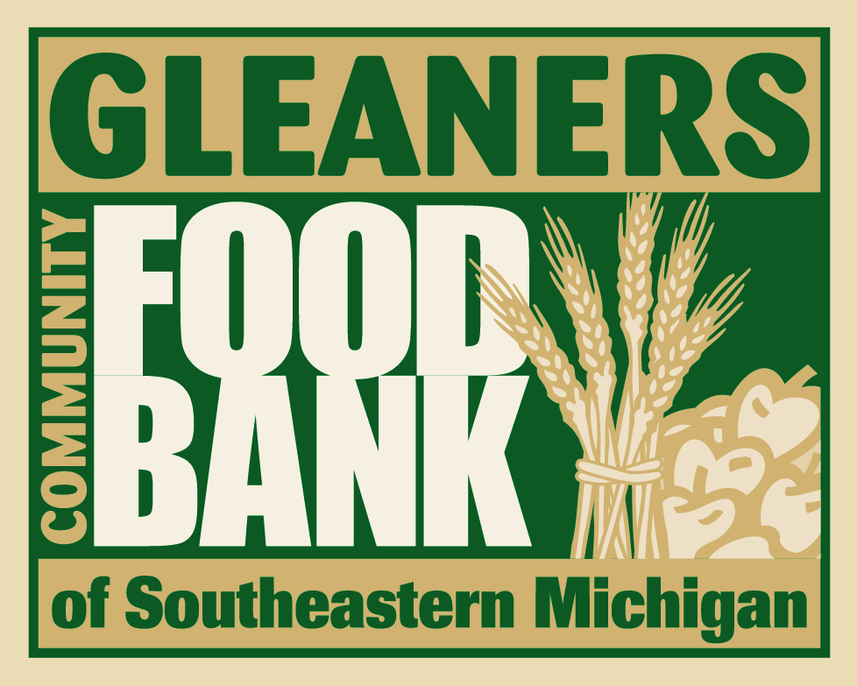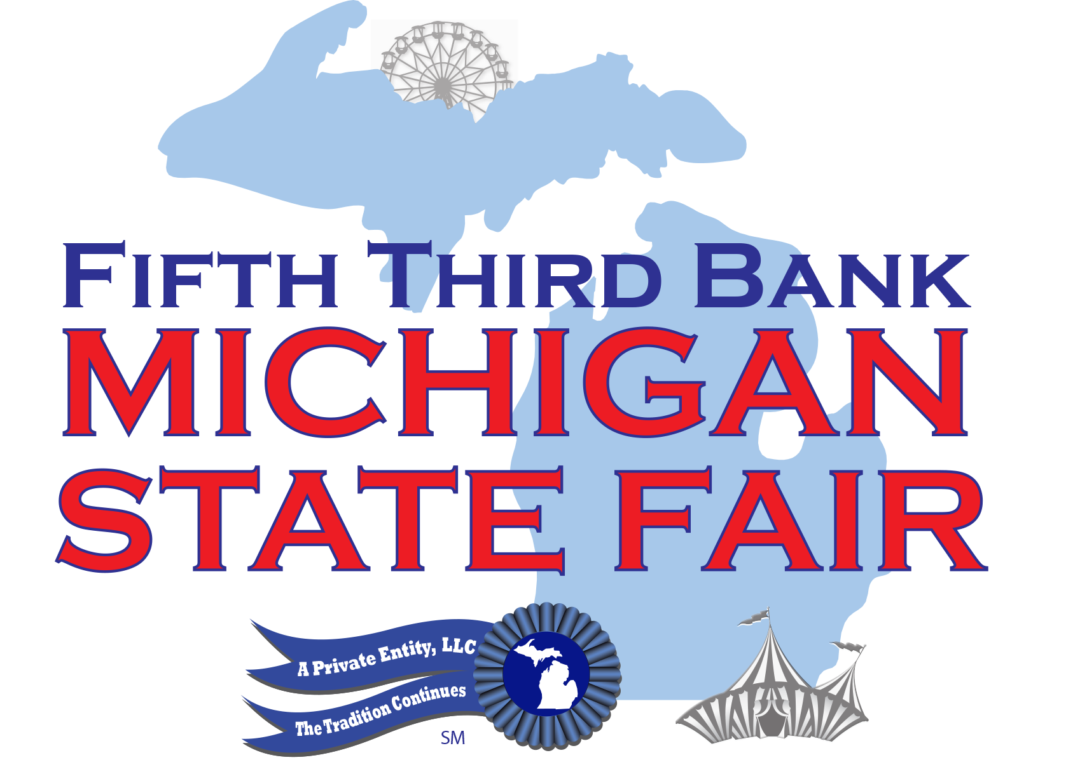

Fifth Third Bank Michigan State Fair Canned Food Drive
for Gleaners Community Food Bank
Thursday, September 1, 2016 Only!

Bring three non-perishable canned food items to the gate and receive $5.00 off an Ultimate Full Price Wristband, regular price $30.00

Novi, MI: The Fifth Third Bank Michigan State Fair is adding another day of family fun, now open on Thursday September 1 through Monday September 5 at the Suburban Collection Showplace, 46100 Grand River Ave in Novi. On the opening day of the 2016 Michigan State Fair, guests will be able to save $5.00 off the price of a full price, Ultimate Wristband, which includes all access to Chrysler Pacifica Carnival Midway Rides, Shrine Circus Performances, Entertainment stages, Ram Truck Livestock and Horse Show Pavilions, Ultimate Ram Truck Test Drive Experience and Kroger Michigan Made Product Pavilion, among other attractions.

“We are very grateful to be able to share the new opening day of the Michigan State Fair with Gleaners Food Bank,” says Steve Masters, Executive Director of the Michigan State Fair, LLC, “This is a terrific opportunity for fairgoers to help provide stock for their shelves, and help those in need heading into the cold weather season.”

For additional information, please contact Nancy Phares 248.390.7340 nphares@MichiganStateFairLLC.com

