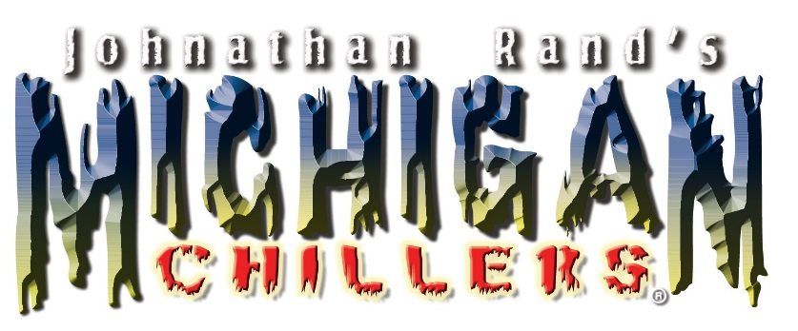

First Annual Reader’s Roundup at the Michigan State Fair!

NOVI, MI: The Fifth Third Bank Michigan State Fair, September 1-5 at the Suburban Collection Showplace in Novi, celebrates Michigan’s literary traditions with a special appearance Thursday September 1 by popular young adult book author Jonathon Rand, creator of the Michigan Chillers and American Chillers mystery book series, presented by Chrysler Pacifica and the Novi Public Library! It’s a grand kick off to a weekend long “Reader’s Round-Up” featuring a broad slate of talented Michigan authors that will be visiting the State Fair to meet readers of all ages and sign books for their fans, Thursday September 1 through Monday September 5 at the Suburban Collection Showplace, 46100 Grand River Ave in Novi. Advance State Fair Tickets are available at all Southeast Michigan Kroger stores and at www.MichiganStateFairLLC.com

The grand old traditions surrounding the Michigan State Fair recall a simpler time; when books were a primary source of knowledge and entertainment, encourage us to revisit rituals and pastimes of an earlier age. From tending the earth, planting, harvesting and preserving foods, to storytelling, community gathering and sharing of resources, it is all about slowing down and a return to our roots in an increasingly fast paced 21st Century society.

Johnathan Rand has been called one of the most prolific authors of this century! He has authored more than 75 books since the year 2000, with well over 4 million copies in print. His series include the wildly popular MICHIGAN CHILLERS, AMERICAN CHILLERS, FREDDIE FERNORTNER, FEARLESS FIRST
GRADER, and THE ADVENTURE CLUB. He also co-authored a novel for teens with Christopher Knight, entitled PANDEMIA. When not traveling, Johnathan and his wife reside in Northern Michigan with their three dogs. He is also the only author in the world that has a store that sells only his works: CHILLERMANIA is located in Indian River, Michigan.
Many additional talented Michigan Authors of books for all ages will also be participating in Reader’s Roundup, presented by Chrysler Pacifica! Current schedule available at www.MichiganStateFairLLC.com

Christopher Paul Curtis "Bud, Not Buddy" http://www.nobodybutcurtis.com/

Bashar Salame- "Let's Change That" http://www.basharsalame.com/

Jean Alicia Elster "The Colored Car" http://www.jeanaliciaelster.com/

Paul Labaere "Brick by Brick, Building our Families Mission" Leigh Arrathoon "Jody's Michigan Adventure"
Ethriam Cash Brammer

Patty O Brien Novak http://www.pattyobriennovak.com/www.PattyOBrienNovak.com/Welcome.html

Lisa Rivard http://lisarivardbooks.com/

Kris Yankee and Marian Nelson: High 5 for Character book series www.High5forCharacter.com

Tom Daldin, Jim Edelman and Eric Tremonti, Under the Radar Michigan, the First 50 episodes www.UTRMichigan.com

For additional information and interviews, please contact Nancy Phares, 248.390.7340 nphares@MichiganStateFairLLC.com

