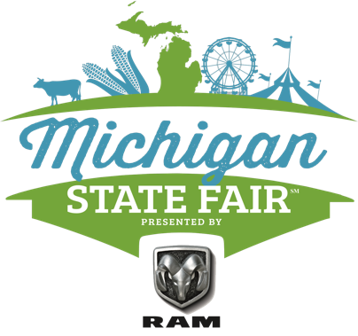

For Immediate Release
Contact: McKenzie Bowman | Email: mckenzie@suburbanshowplace.com | Phone: (248) 760-4256

Charity Preview Night Kicks Off the 2021 Michigan State Fair with an Exclusive Opportunity for Charitable Organizations to Enjoy the Fair the Night Before Officially Opening to the Public

Novi, MI – September 1st, 2021 - The Michigan State Fair presented by Ram Trucks will be kicked off on Wednesday night with a private invite only Charity Sneak Peek where children currently undergoing treatment at local Shriners Hospitals for Children and many other charitable organizations are invited for a special access night of fun before the fair officially opens on Thursday.

The evening will start with a Ribbon Cutting ceremony welcoming the children and their families into the fair lead by Rochester High School Marching Band. From there the Charity preview guests get to enjoy the full fair with minimal lines and no crowds, offering them an exclusive VIP experience they’ll never forget!
Giving back to the community has always been at the center of the organization since the inception in 2013. In the eight years since they have been in existence, the Michigan State Fair LLC has given a total of $3,319,000 in the form of charitable, financial, and in-kind contributions to community organizations, scholarship recipients, and various charities.
The Michigan State Fair, LLC, presented by Ram Trucks, is a private enterprise that continues to grow and evolve, based on the legacy of the original Michigan State Fair, which debuted in 1849 but was discontinued due to ongoing budget issues. Following several years of exploratory discussions amongst local leaders and elders in the state agriculture industry, a new Michigan State Fair business model began to emerge; the only one of its kind in North America.

The Michigan State Fair, LLC, presented by Ram Trucks, is devoted to the ongoing development and support of agriculture, business entrepreneurship, and family entertainment, while preserving the legacy and beloved traditions of the original State Fair. This privately produced event carries forward all of the positive aspects of past Fairs, including substantial positive economic impact, with major charitable and community benefits, all with no burden to the taxpayer.

If you are a charitable organization that would like to get involved please see www.michiganstatefairllc.com/charitysneakpeakFOF to apply.

Fair Hours:
Thursday, Sept. 2nd – Friday, Sept. 3rd: 11am-10pm

Saturday, Sept. 4th – Sunday, Sept. 5th: 10am-10pm

Monday, Sept. 6th:10am-9pm
Interior Livestock Halls will close at 5pm
Interior Vendor Hall will close at 7pm
The Midway and outside will be open till 9pm

Ticket Prices:
Ultimate Wristband: $30.00
Includes Fair Entry, Unlimited Carnival Rides and Circus Performances
Fair Only Admission: Adult - $8.00 | Children - $6.00
Includes entry into the Fair only --- NO carnival rides or circus*

Friday Night Flights (Friday, Sept 3rd only)
Includes fair entry*
VIP Early Admission $15 - 4:30 p.m. - 9:30 pm – 10 samples
Regular Admission $10 – 5:30pm – 9:30pm – 6 samples

*Options to upgrade to rides and/or circus once inside

For more information on tickets and hours visit www.michiganstatefairllc.com/tickets.

Website: www.michiganstatefairllc.com
Facebook: https://www.facebook.com/MichiganStateFair
Instagram: @michiganstatefair
Twitter: @MiStateFair1

